

Infrared No-Touch Forehead Thermometer performance test report

Sample name: Infrared No-Touch Forehead Thermometer
Model: PT9L
Date: July 11, 2024


Test Report Home Page
Page 1 of 5 pages
Sample Name | Infrared No-Touch Forehead Thermometer | Sample No. | YP2407017
Model | PT9L | sample quantity | 1 unit
Number | LOT No.：KE04 | Test Place | Area B,Testing Center
Environment | 16℃~24℃，40%RH~64%RH | Test Date | On July 10,2024,  On July 11,2024
Test Items | Accuracy
Reference documents for the test | Infrared No-Touch Forehead Thermometer Product Accelerated Testing Protocol
Test Conclusion | The accuracy of the tested Infrared No-Touch Forehead Thermometer meets the requirements of the Infrared No-Touch Forehead Thermometer Accelerated Life Test Protocol.  Report date: July 11,2024
Remarks | The damp-heat aging test was carried out by Tianxu(Tianjin)Testing Technology Service Co.,LTD.

Approver: Prepared:

1 | Accuracy | 33.0℃±0.3℃； | 0.0℃ | Meet the requirement | —
 |  | 37.0℃±0.2℃； | -0.1℃ | Meet the requirement | —
 |  | 41.0℃±0.2℃ | -0.1℃ | Meet the requirement | —
Following of this page blank

The damp-heat Accelerated aging test
Temperature: 40℃; Humidity: 95% RH; Time: 14.8h
1 | Accuracy | 33.0℃±0.3℃； | -0.1℃ | Meet the requirement | —
 |  | 37.0℃±0.2℃； | -0.2℃ | Meet the requirement | —
 |  | 41.0℃±0.2℃ | 0.0℃ | Meet the requirement | —
Following of this page blank

Photos of Samples and Accessories
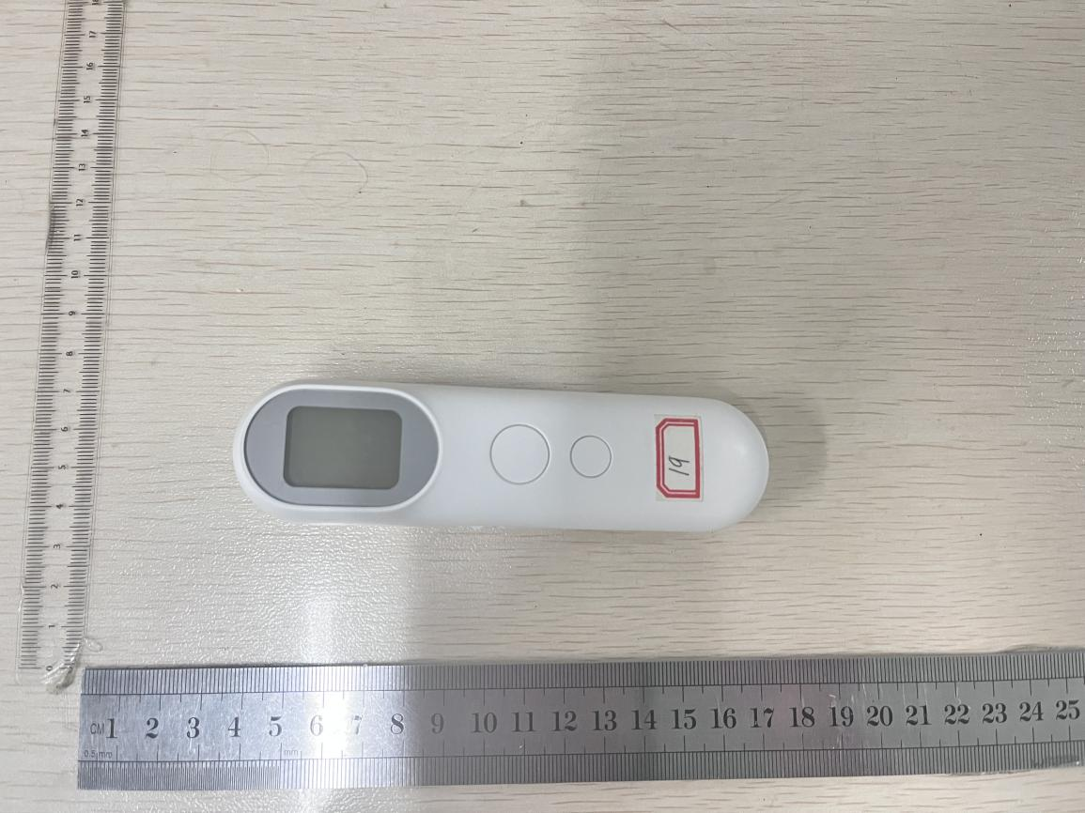
Front of the Infrared No-Touch Forehead Thermometer
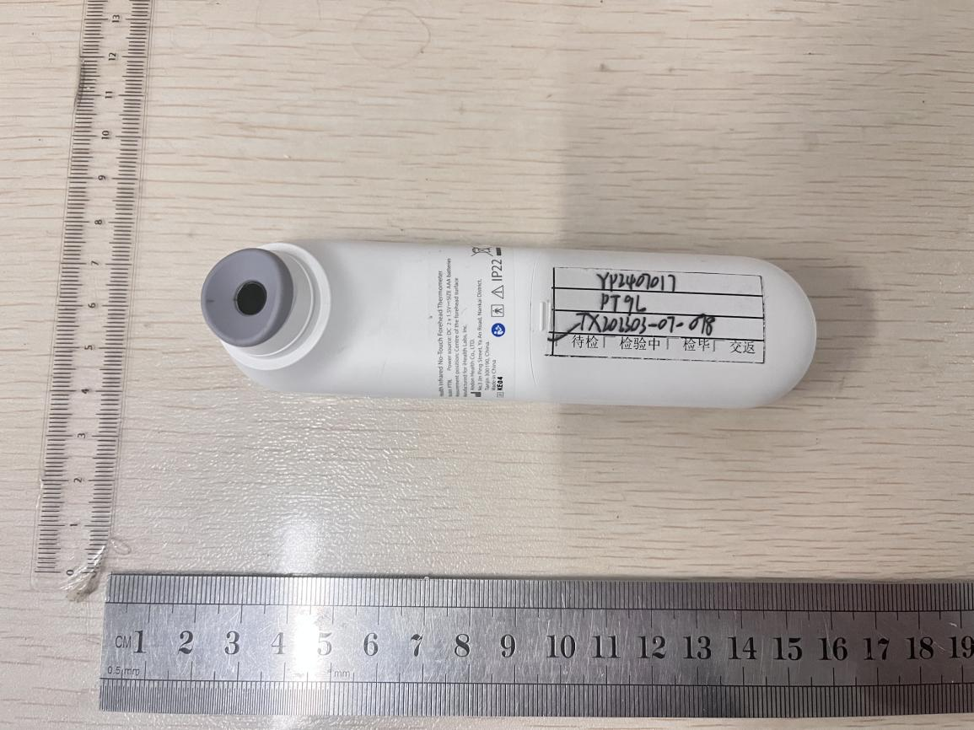
Back of the Infrared No-Touch Forehead Thermometer

Photos of Samples and Accessories
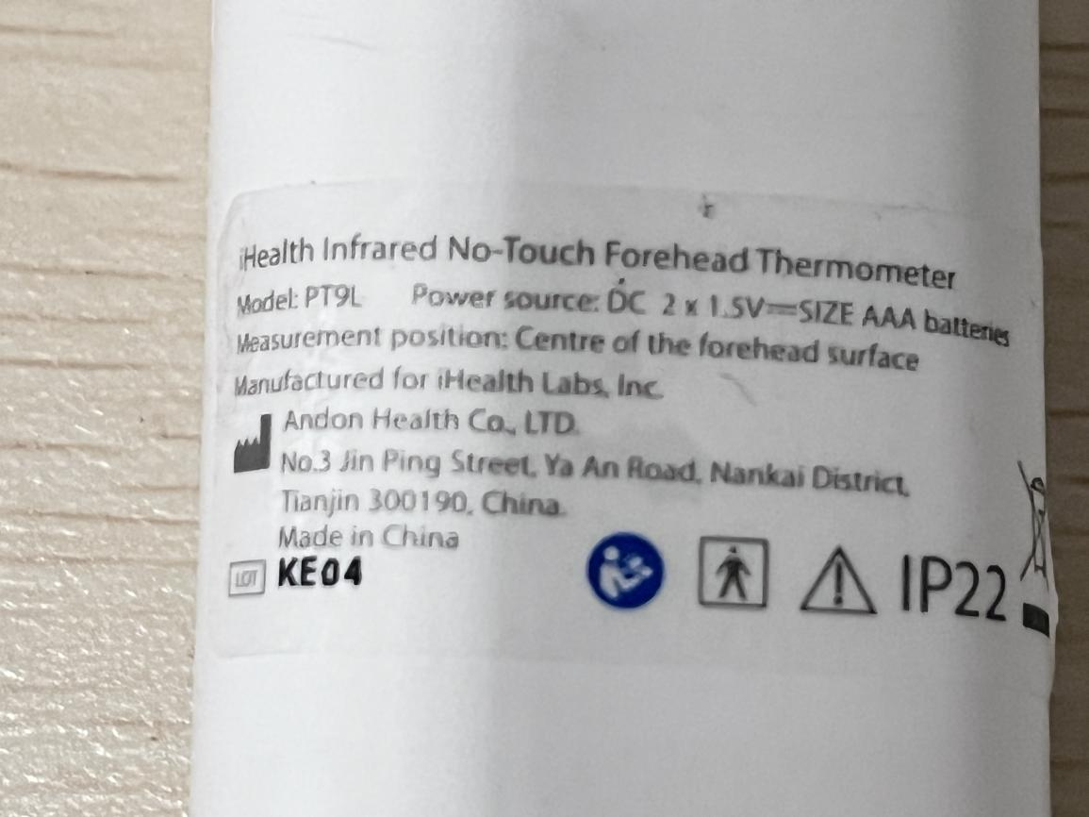
Nameplate of the Infrared No-Touch Forehead Thermometer
Description of the Sample and Condition
- The tested sample includes: 1 pcs Infrared No-Touch Forehead Thermometer.
- The basic functions of the sample are normal before and after the test.

Following of this page blank

